
CSA0501-DATABASE MANAGEMENT SYSTEMS

LAB EXPERIMENTS DATE: 08/07/2026

EXPERIMENT 1 -- DDL Commands (CREATE, ALTER, DROP, TRUNCATE, RENAME)

AIM:

To create and manage the database structure for a Flight Reservation System using Data Definition Language (DDL) commands such as CREATE, ALTER, DROP, TRUNCATE, and RENAME.

PROCEDURE:

- Open MySQL and create the database for the Flight Reservation System.
- Use the CREATE command to create required tables such as Flight, Passenger, and Booking with suitable attributes and data types.
- Use the ALTER command to add, modify, or remove columns from an existing table.
- Use the RENAME command to change the name of an existing table.
- Use the TRUNCATE command to remove all records from a table while keeping its structure.
- Use the DROP command to permanently delete an unwanted table from the database.
- Use DESC table_name; or SHOW TABLES; after the operations to verify the changes.
- Execute each command and observe the output to ensure that all DDL operations are performed successfully.

PROGRAM:

- CREATE DATABASE

CREATE DATABASE Flight_Reservation;
Then select the database:

USE Flight_Reservation;

OUTPUT:

- CREATE TABLE

CREATE TABLE Flight (
Flight_ID INT PRIMARY KEY,
Flight_Name VARCHAR(50),
Source VARCHAR(50),
Destination VARCHAR(50),
Departure_Time TIME,
Price DECIMAL(10,2)
);
DESC Flight;

OUTPUT:

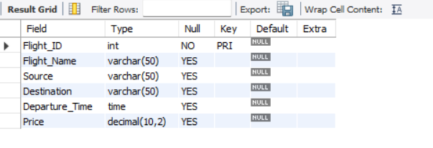

3.ALTER – ADD COLUMN

Add a new column called Available_Seats:

ALTER TABLE Flight
ADD Available_Seats INT;
DESC Flight;

OUTPUT:

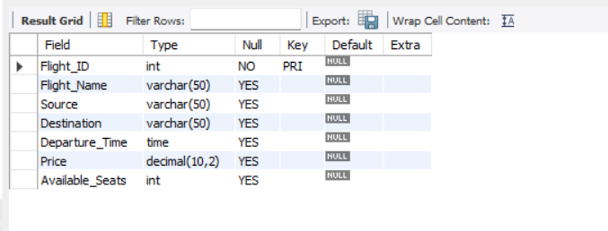
- ALTER – MODIFY COLUMN

Change the size of Flight_Name:

ALTER TABLE Flight
MODIFY Flight_Name VARCHAR(100);
DESC Flight;

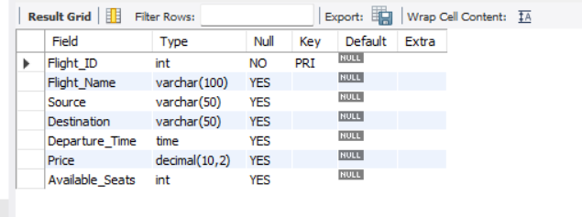

- ALTER – DROP COLUMN

Remove the Available_Seats column:

ALTER TABLE Flight
DROP COLUMN Available_Seats;
DESC Flight;

OUTPUT:

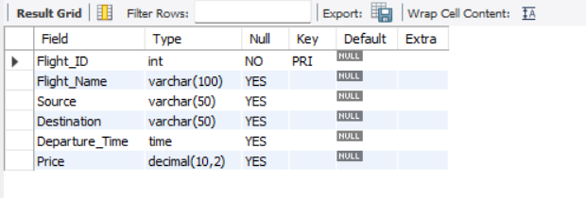

- RENAME TABLE

Rename Flight to Flight_Details:

RENAME TABLE Flight TO Flight_Details;
SHOW TABLES;

OUTPUT:

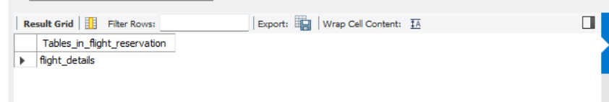

- INSERT SAMPLE DATA
You need some data before testing TRUNCATE.

INSERT INTO Flight_Details
VALUES
(101, 'IndiGo', 'Chennai', 'Delhi', '10:30:00', 6500.00),
(102, 'Air India', 'Chennai', 'Mumbai', '14:00:00', 7200.00);
SELECT * FROM Flight_Details;

OUTPUT:

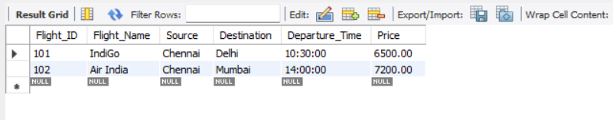

- TRUNCATE TABLE

TRUNCATE TABLE Flight_Details;
Check:

SELECT * FROM Flight_Details;

The table will be empty, but the table still exists.

OUTPUT:

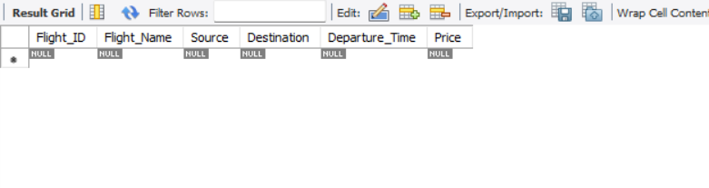
- DROP TABLE
It completely removes the table.

DROP TABLE Flight_Details;
SHOW TABLES;
OUTPUT:

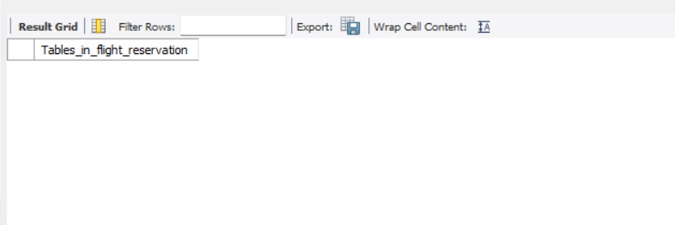

RESULT:

Thus the DDL commands executed successfully.

